TEST CASES DOCUMENT -

CARAVEL -

UPDATE RATE FOR PRICE LEVEL

**Test Case 1: -**

1. Script should update ‘Rate’ for current ‘Price Level’ on ‘New Store Transfer to SO’ record Id = 5860, If ‘Amount’ is changed for that ‘Price Level’ on ‘Inventory Item’ record Id = 22.

**Screenshots: -**

Base Price for USD Pricing is changed to ‘4.30’ in Inventory Item Id = 22.

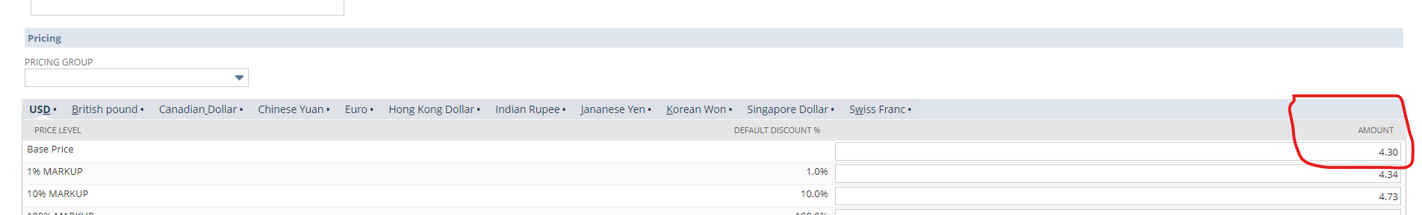

Before executing script, Rate is ‘2,344.30’ for Inventory Item Id = 22 on ‘New Store Transfer to SO’ record = 5860.

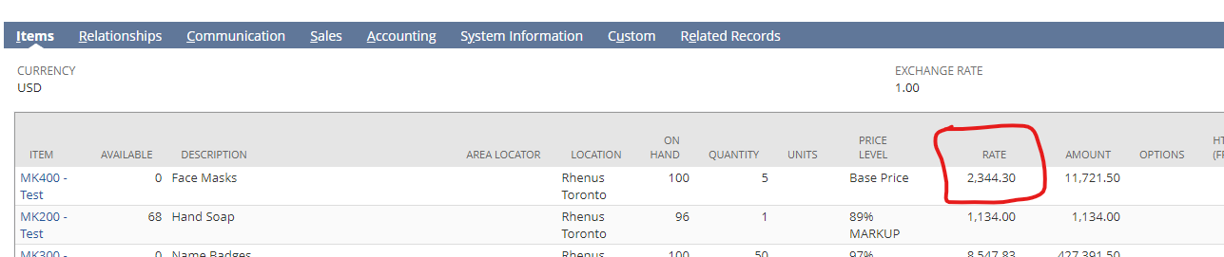

After executing script, Rate is updated to ‘4.30’ for Inventory Item Id = 22 on ‘New Store Transfer to SO’ record = 5860.

Note: - Rate update after reloading the record.

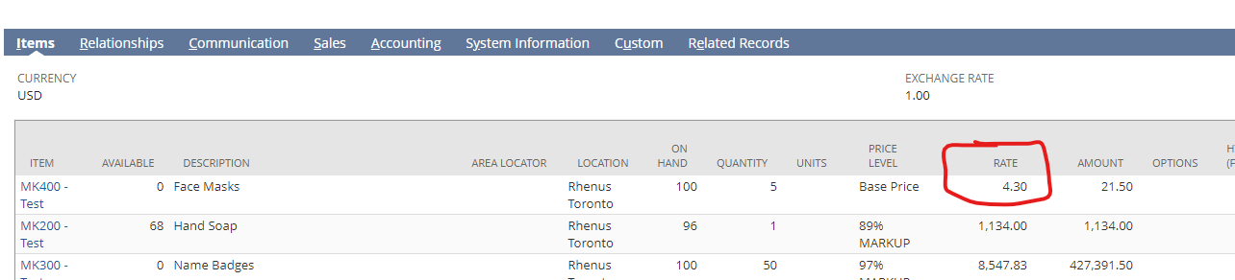

**Test Case 2: -**

1. Script should Not Update ‘Rate’ for current ‘Price Level’ = ‘Custom’ on ‘New Store Transfer to SO’ record Id = 7561. Because ‘Custom’ Price Level not Present in ‘Pricing Group’ on ‘Inventory Item’ record.

**Screenshots: -**

Select ‘Price Level’ is ‘Custom’ for Inventory Item = ‘MK200 - Test’ in ‘New Store Transfer to SO’ record.

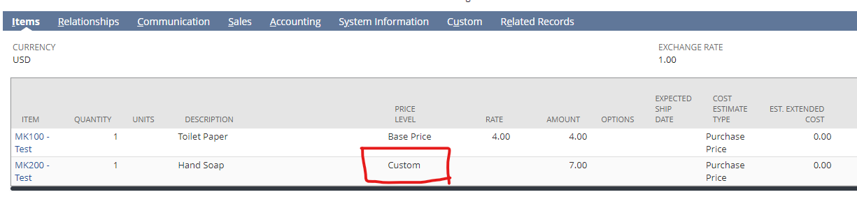

After executing the script, ‘Rate’ is Blank because ‘Custom’ Price Level is not present on that Item.

